End User Email Templates
Transitioning to Advarra SSO for CIRBI

Overview
This document contains email templates you can use to communicate the transition to Advarra SSO for CIRBI to CIRBI users at your organization. There are two versions below:
- For users who already have an Advarra SSO account
- For users who need to set up their Advarra SSO account
Instructions for sending:
Please send the appropriate version to users at your organization to inform them of the transition. Before sending, be sure to insert the [date] users will receive their activation email. Advarra will provide your organization’s activation date to you via email at least one week prior to your transition.
__________________________________________________________________________________________________________________

For users who already have an Advarra SSO account
Subject Line: CIRBI Login Process Changing [date of activation email]
Starting [date of activation email], your Advarra CIRBI next-generation account will use Advarra Single Sign-On (SSO). This means you’ll be able to access CIRBI (and any other SSO-enabled Advarra applications you use) from the Advarra One homepage using your Advarra SSO login credentials.
What do I need to do?
You will receive an automated email from no-reply@advarracloud.com on [date of activation email]. Since you already have an Advarra SSO account, the email will inform you that you now have access to the CIRBI tile from the Advarra One homepage. No additional action is required. Please find an example of this email below.
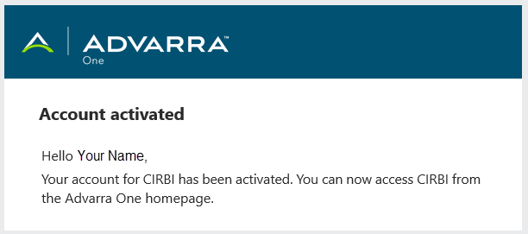
IMPORTANT: Once you start logging in via Advarra SSO to access an application, we recommend replacing your current bookmarked URLs with https://login.advarracloud.com.
What resources are available if I need help?
- Advarra SSO for CIRBI Walkthrough - Learn how to create your Advarra SSO account and access CIRBI through Advarra One.
- Advarra SSO page on the CIRBI Next-Generation Documentation site - This page contains general information about Advarra SSO for CIRBI including general navigation tips, account setup, and more.
- SSO Help Center - For further support, visit the SSO Help Center (available on the Advarra One login page).

If you have questions about the transition to Advarra SSO for CIRBI, please contact support-CIRBI@advarra.com.

For users who need to set up their Advarra SSO account
Subject Line: CIRBI Login Process Changing [date of activation email]
Starting [date of activation email], your Advarra CIRBI next-generation account will use Advarra Single Sign-On (SSO). This means you’ll be able to access CIRBI (and any other SSO-enabled Advarra applications you use) from the Advarra One homepage using a single set of Advarra SSO login credentials.
What do I need to do?
You will receive an automated email from no-reply@advarracloud.com in the coming weeks. The email will contain a link to complete your one-time Advarra SSO account setup. Please find an example of this email below.
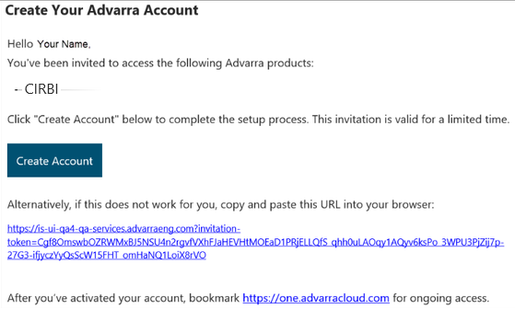
Complete the following steps to create your Advarra SSO account:
  - Click the “Create Account” link in the email.
  - Register for your Advarra SSO account using your own organizational credentials. You must accept the Terms and Conditions.
  - After your account is set up and you log in to Advarra One using your Advarra SSO account credentials, all SSO-enabled applications to which you have access will be available on the Advarra One homepage.
  - After signing in to Advarra SSO, you'll see the CIRBI tile on the Advarra One homepage. Click the tile to open CIRBI next-generation.
IMPORTANT: Once you start logging in via Advarra SSO to access an application, we recommend replacing your current bookmarked URLs with https://login.advarracloud.com.
What resources are available if I need help?
- Advarra SSO for CIRBI Walkthrough - Learn how to create your Advarra SSO account and access CIRBI through Advarra One.
- Advarra SSO page on the CIRBI Next-Generation Documentation site - This page contains general information about Advarra SSO for CIRBI including how to reset your password, general navigation tips, account setup, and more.
- SSO Help Center - For further support, visit the SSO Help Center (available on the Advarra One login page).

If you have questions about the transition to Advarra SSO for CIRBI, please contact support-CIRBI@advarra.com.

